Screenshot 01: The app is able to add and subtract from the balance. The balance is calculated above.

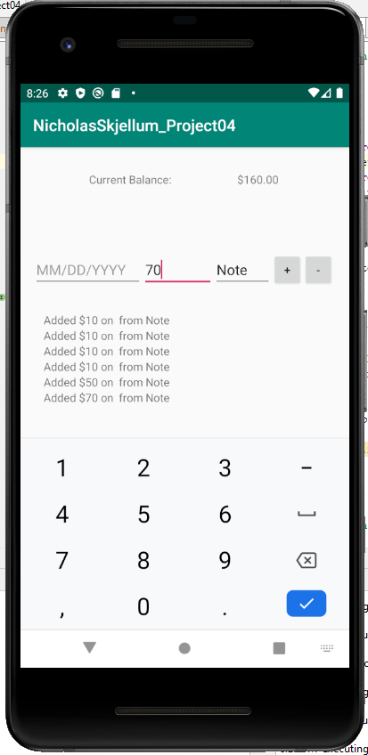

Screenshot 02: I was unable to restore the history of the program. The balance from the previous use is saved.

